

**FPT STUDENT BLOG**

**Software Design Document**

**Prepared by Group 1 - SE1504**

**Nguyễn Thiện Quang**

**Nguyễn Dương**

**Lê Anh Khoa**

**Bùi Thị Thùy Linh**

**Trần Trọng Nhân**

– Ho Chi Minh, November 2021 –

**Table of Contents**

**I. Overview** **5**

1. Code Packages/Namespaces 5

2. Database Schema 6

**II. Code Designs** **8**

1. Login 8

a. Class Diagram 8

b. Sequence Diagram(s) 9

c. Database queries 9

2. Create post 9

a. Class Diagram 9

b. Sequence Diagram(s) 10

c. Database queries 10

3. Comment 10

a. Class Diagram 10

b. Sequence Diagram(s) 11

c. Database queries 11

4. Create Notification 11

a. Class Diagram 11

b. Sequence Diagram(s) 12

c. Database queries 12

5. Detail Post 12

a. Class Diagram 12

b. Sequence Diagram(s) 13

c. Database queries 13

6. Vote 13

a. Class Diagram 13

b. Sequence Diagram(s) 14

c. Database queries 14

7. Edit Post 14

a. Class Diagram 15

b. Sequence Diagram(s) 15

c. Database queries 15

8. Search Post 15

a. Class Diagram 16

b. Sequence Diagram(s) 16

c. Database queries 16

9. Edit Profile 16

a. Class Diagram 17

b. Sequence Diagram(s) 17

c. Database queries 17

10. Create Mentor 17

a. Class Diagram 18

b. Sequence Diagram(s) 18

c. Database queries 18

11. Add Category 18

a. Class Diagram 19

b. Sequence Diagram(s) 19

c. Database queries 19

12. Update Category 19

a. Class Diagram 20

b. Sequence Diagram(s) 20

c. Database queries 20

13. Ban User 20

a. Class Diagram 20

b. Sequence Diagram(s) 21

c. Database queries 21

14. Approve Post 21

a. Class Diagram 22

b. Sequence Diagram(s) 22

c. Database queries 22

15. Deny Post 22

a. Class Diagram 22

b. Sequence Diagram(s) 23

c. Database queries 23

16. Sign up 23

a. Class Diagram 23

b. Sequence Diagram(s) 24

c. Database queries 24

17. Logout 24

a. Class Diagram 24

b. Sequence Diagram(s) 25

# I. Overview

## 1. Code Packages/Namespaces

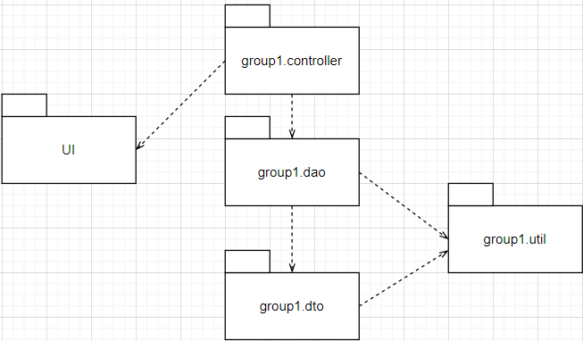

***Package descriptions & package class naming conventions***

| **No** | **Package** | **Description** |
| --- | --- | --- |
| 01 | group1.controller | Controllers are used to handle user requests and then communicate with the model  - AddCategoryController  - ApproveDenyPostController  - CategoryController  - CommentController  - CreateAccountController  - CreateNotificationController  - CreatePostController  - CreateMentorController  - EditPostController  - EditProfileController  - GetPostByTagController  - GoogleController  - HideUserController  - HomeController  - LoginController  - LogoutController  - MainController  - ManagerController  - ProfileController  - SearchController  - ShowDetailPostController  - SubmitAgainController  - UpdateCategoryController  - UpdateRankController  - ViewPostController  - ViewYourPostController  - VoteController |
| 02 | group1.dao | Set of queries to get data from the database and send it back to the controller  - CategoryDAO  - CommentDAO  - PostDAO  - RankDAO  - ReportDAO  - StatusDAO  - TagDAO  - UserDAO |
| 03 | group1.dto | Variables that store data retrieved from the database  - CategoryDTO  - CommentDTO  - PostDTO  - RankDTO  - ReportDTO  - StatusDTO  - TagDTO  - UserDTO  - UserError |
| 04 | group1.util | Open connection with database  - DBUtils |

## 2. Database Schema

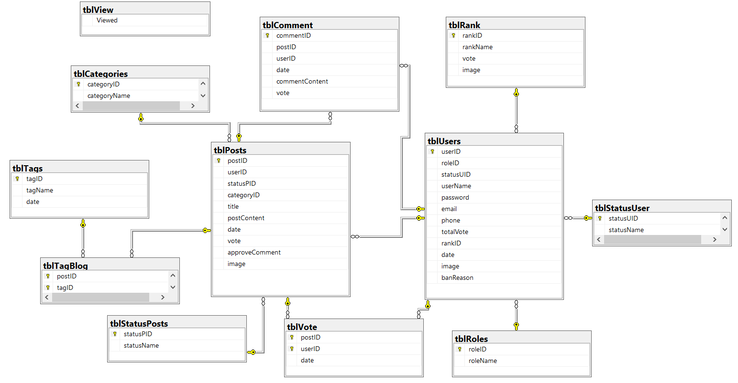

***Table descriptions & package class naming conventions are as below***

| **No** | **Table** | **Description** |
| --- | --- | --- |
| 01 | tblPosts | Table to store posts on the system  - Primary keys: postID  - Foreign keys: categoryID |
| 02 | tblUsers | The table that stores the users in the system  - Primary keys: userID  -Foreign keys: roleID, rankID |
| 03 | tblComment | Table that stores user comments for each post  - Primary keys: commentD  -Foreign keys: postID, userID |
| 04 | tblVote | Table that stores user votes for each article  -Foreign keys: postID, userID |
| 05 | tblCategories | Table to store article categories in the system  - Primary keys: categoryID |
| 06 | tblRank | The table stores the hierarchy of users in the system  - Primary keys: rankID |
| 07 | tblStatusUser | Table to save the state of users in the system  - Primary keys: statusID |
| 08 | tblRoles | Table to store user permissions in the system  - Primary keys: roleID |
| 09 | tblStatusPosts | The table stores the browsing, waiting, or rejecting statuses of articles in the system  - Primary keys: statusPID |
| 10 | tblTagBlog | The table stores the tags included in each article  -Foreign keys: postID, tagID |
| 11 | tblTags | Table to store tags in the system  - Primary keys: tagID |
| 12 | tblView | The table stores the number of users accessing the system |

# II. Code Designs

## 1. Login

### a. Class Diagram

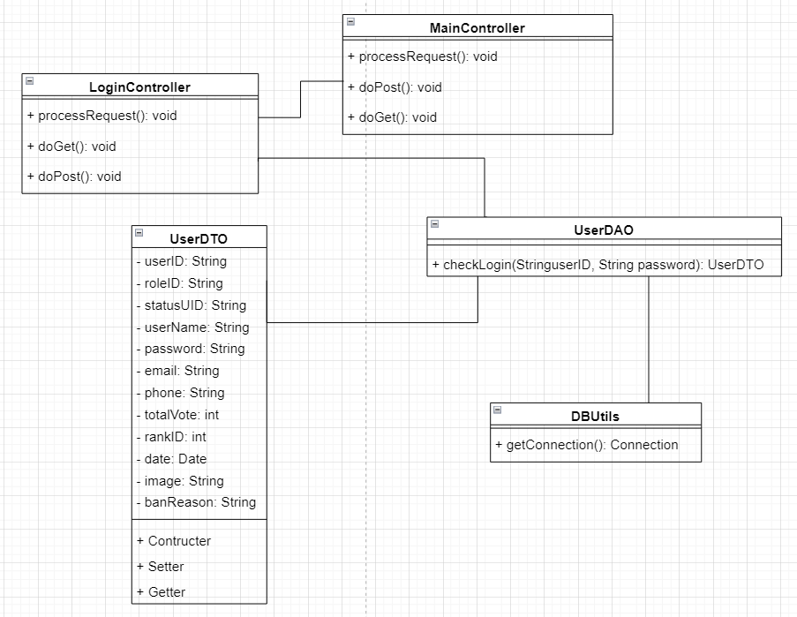

### b. Sequence Diagram(s)

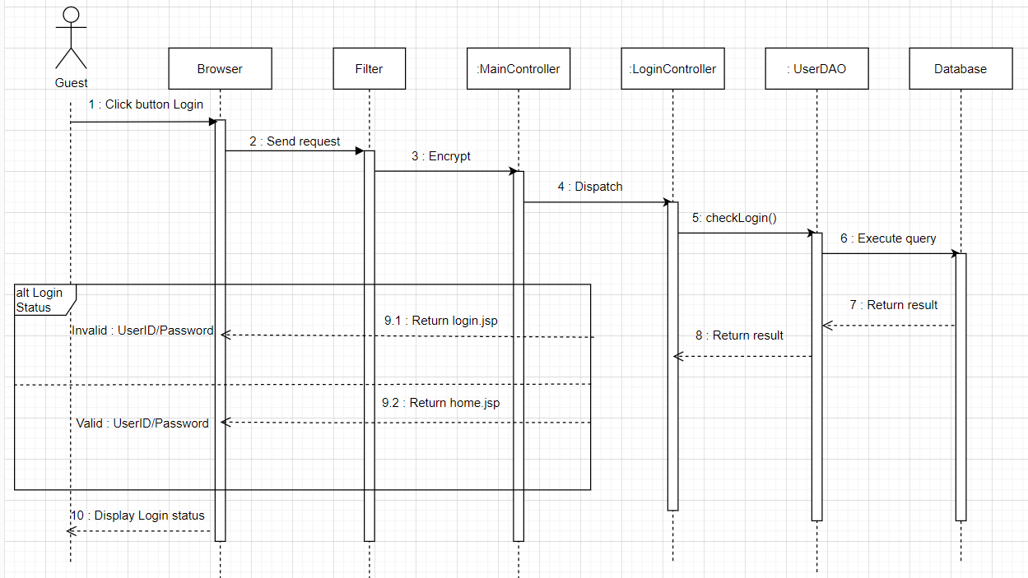

### c. Database queries

* SELECT roleID, statusUID, userName, email, phone, totalVote, rankID, date, image, banReason

FROM tblUsers

WHERE userID=? AND password=?

## 2. Create post

### a. Class Diagram

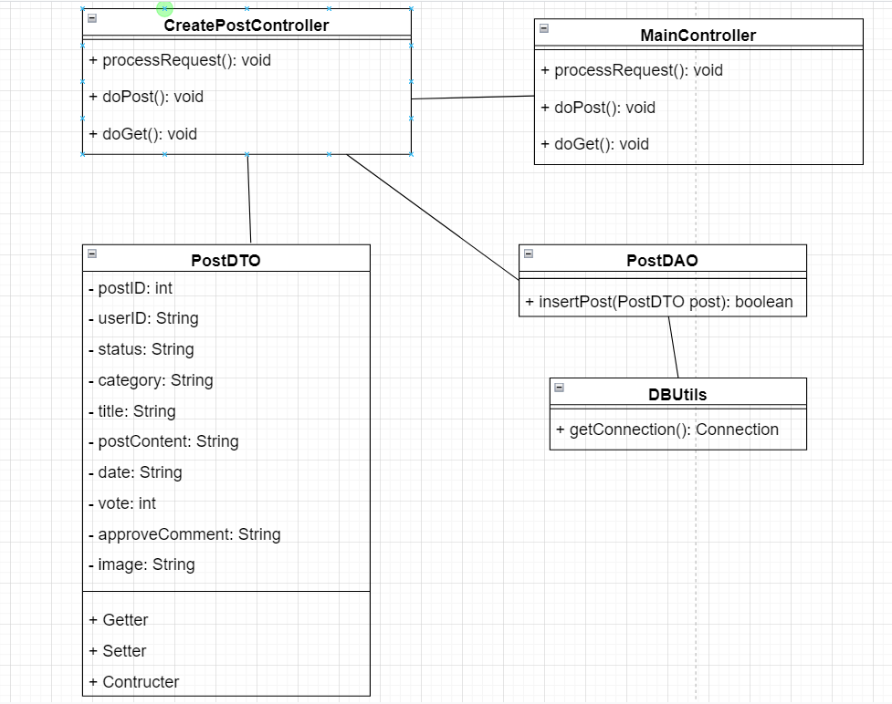

### b. Sequence Diagram(s)

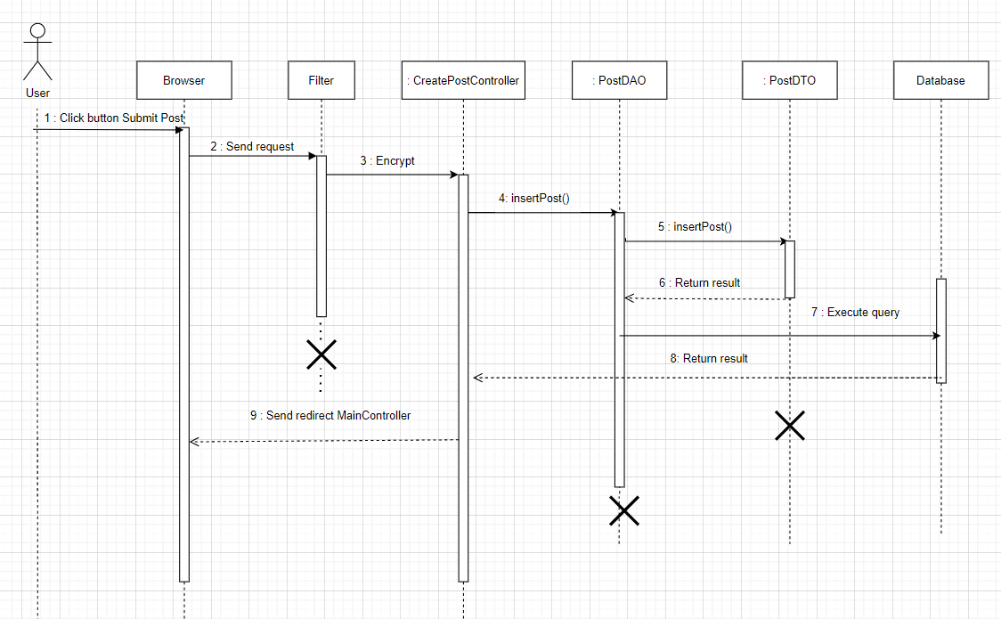

### c. Database queries

* Insert into tblPosts(userID, title, statusPID, categoryID, postContent ,date, vote, image )

values(?,?,?,?,?,?,?,?)

## 3. Comment

### a. Class Diagram

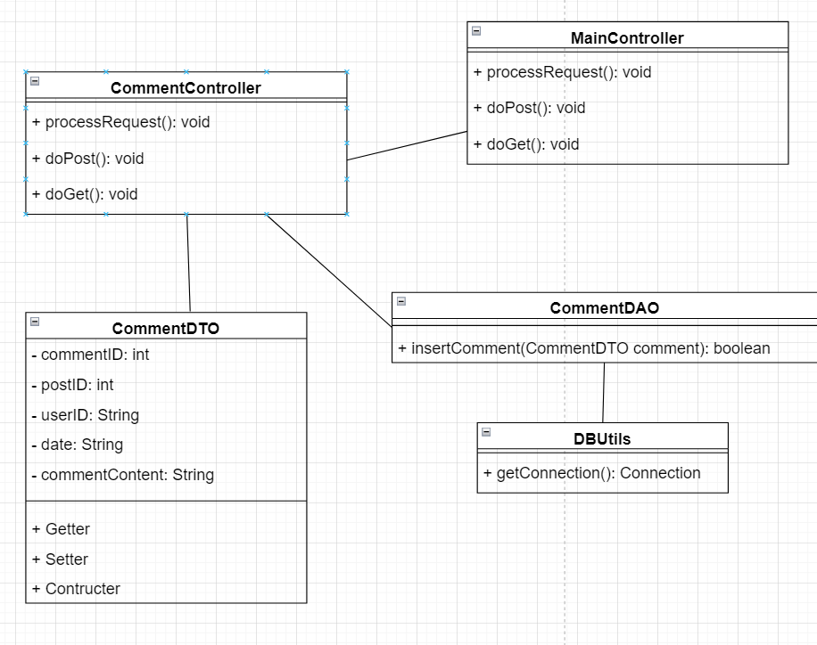

### b. Sequence Diagram(s)

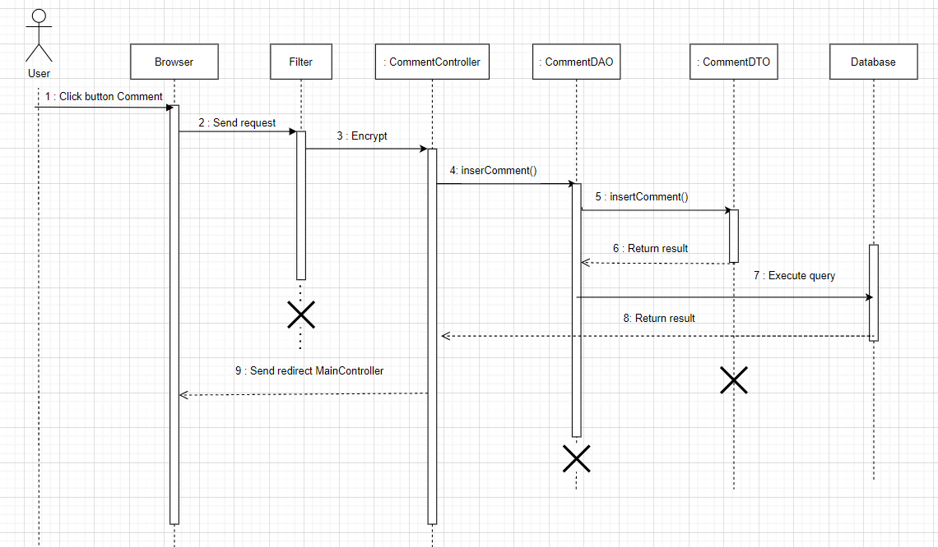

### c. Database queries

* INSERT INTO tblComment(postID, userID, date, commentContent) VALUES(?,?,?,?)

## 4. Create Notification

### a. Class Diagram

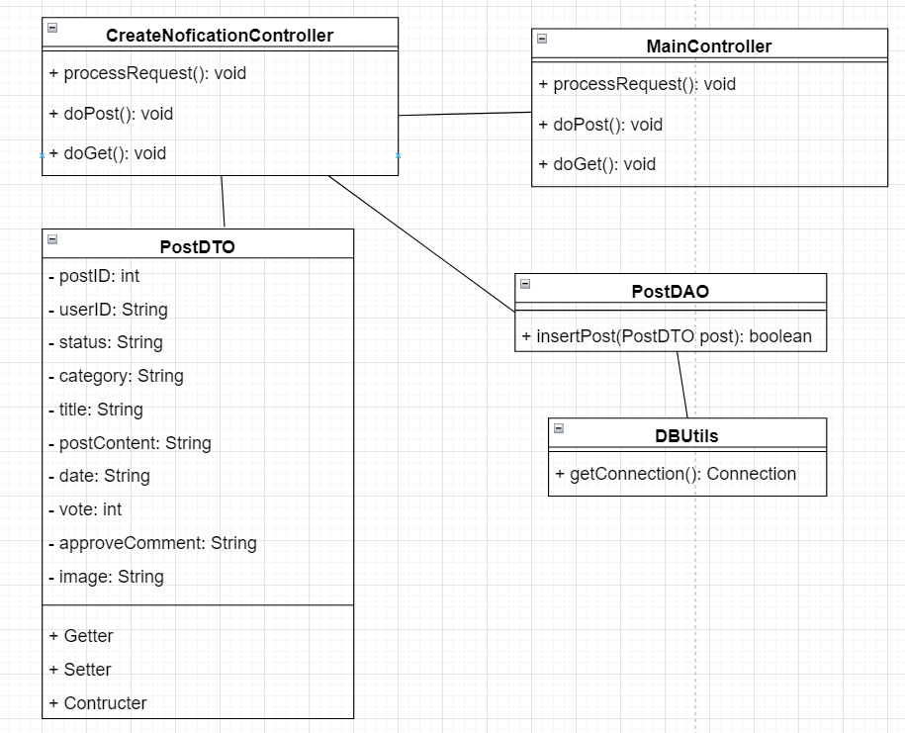

### b. Sequence Diagram(s)

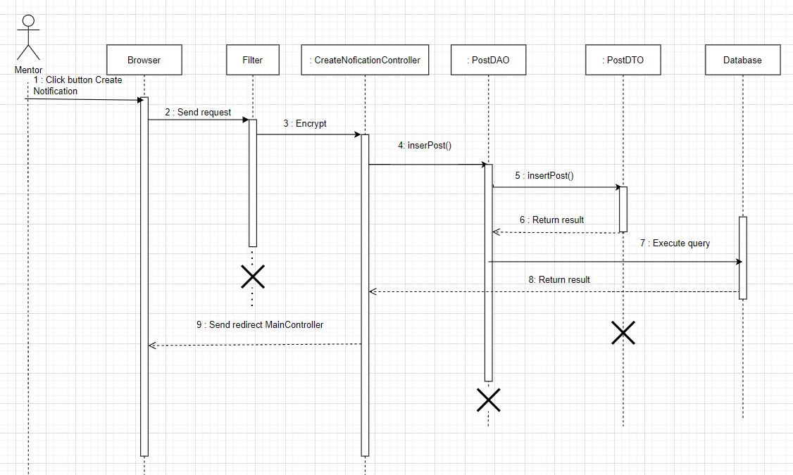

### c. Database queries

* Insert into tblPosts(userID, title, statusPID, categoryID, postContent ,date, vote, image )

values(?,?,?,?,?,?,?,?)

## 5. Detail Post

### a. Class Diagram

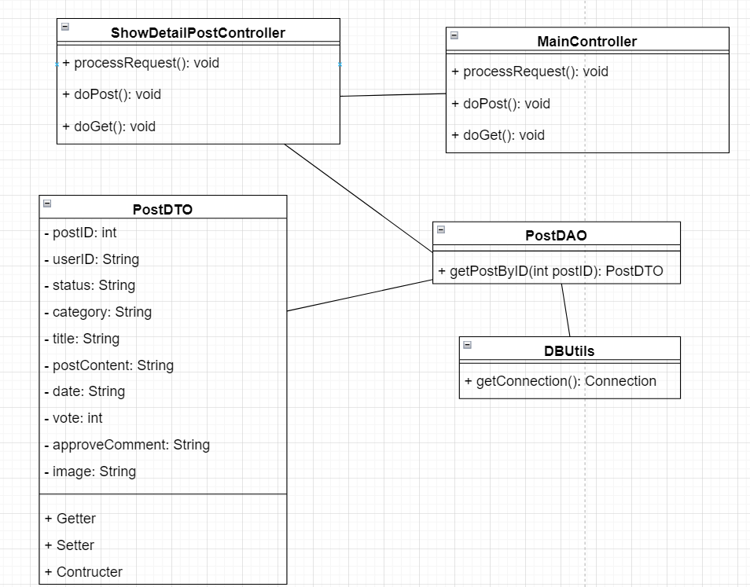

### b. Sequence Diagram(s)

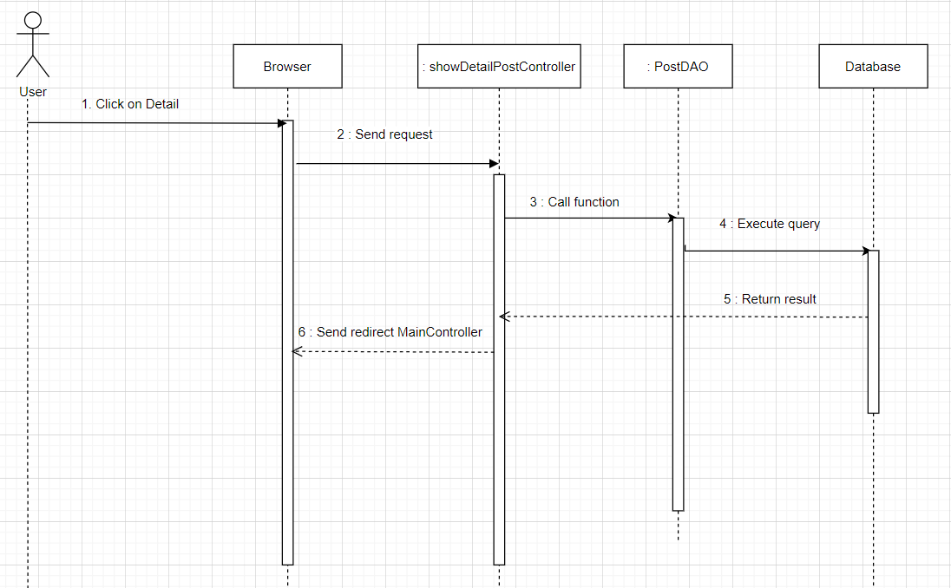

### c. Database queries

* select * from tblPosts where postID=?

## 6. Vote

### a. Class Diagram

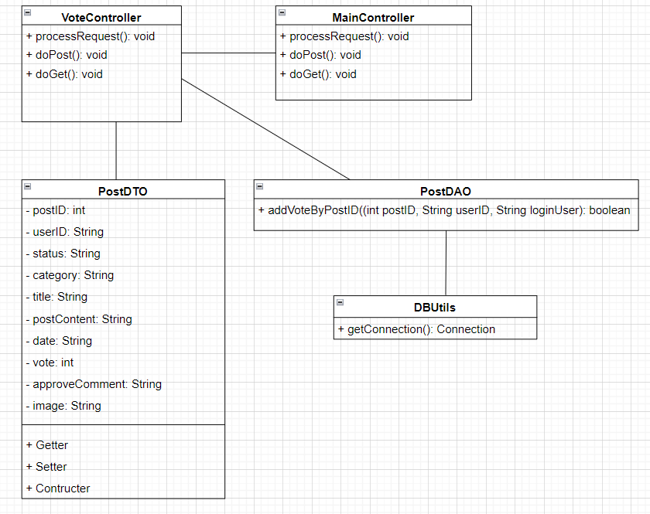

### b. Sequence Diagram(s)

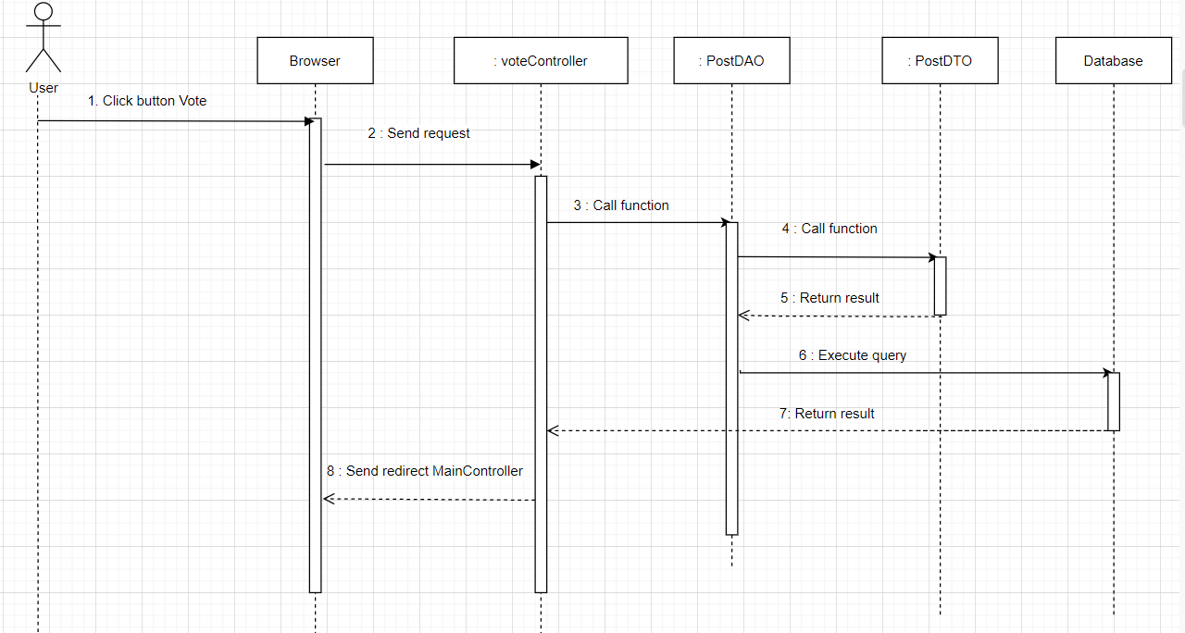

### c. Database queries

UPDATE tblPosts SET vote = vote + 1 WHERE postID = ?

UPDATE tblUsers SET totalVote = totalVote + 1 WHERE userID = ?

Insert into tblVote(postID, userID, date) values(?, ?, ?)

## 7. Edit Post

### a. Class Diagram

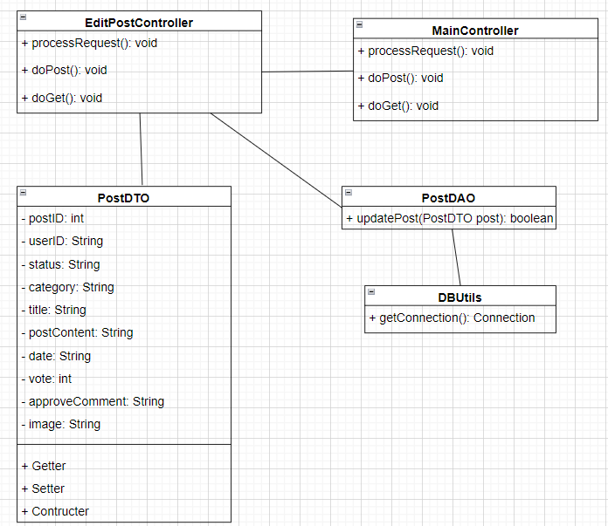

### b. Sequence Diagram(s)

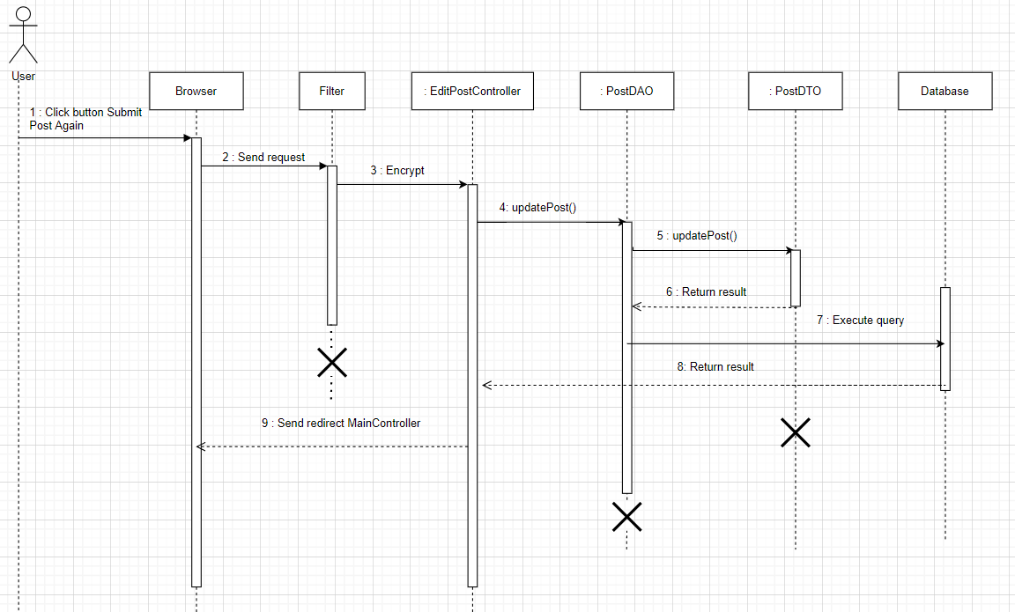

### c. Database queries

Update tblPosts Set userID=?, title=?, statusPID=?, categoryID=?, postContent=?, date=?, vote=?, image=?, approveComment=? Where postID=?

## 8. Search Post

### a. Class Diagram

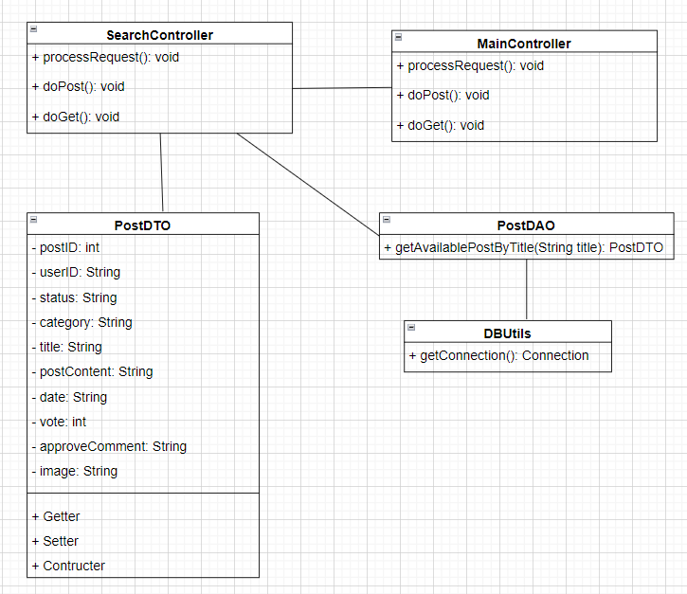

### b. Sequence Diagram(s)

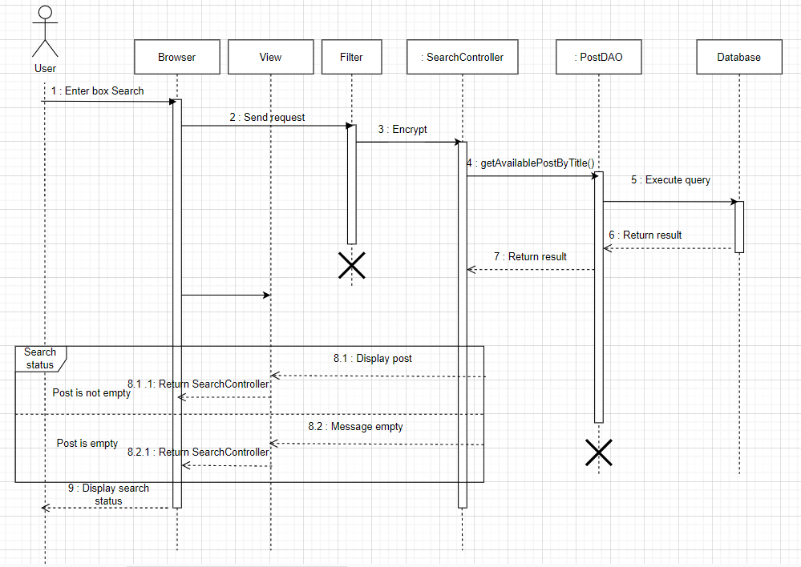

### c. Database queries

Select postID, userID, statusPID, categoryID, title, postContent, date, vote, image From tblPosts

Where does the title LIKE ? and statusPID = ? order by date desc

## 9. Edit Profile

### a. Class Diagram

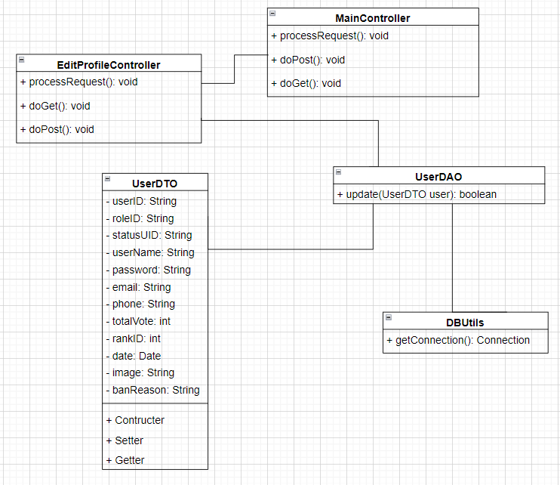

### b. Sequence Diagram(s)

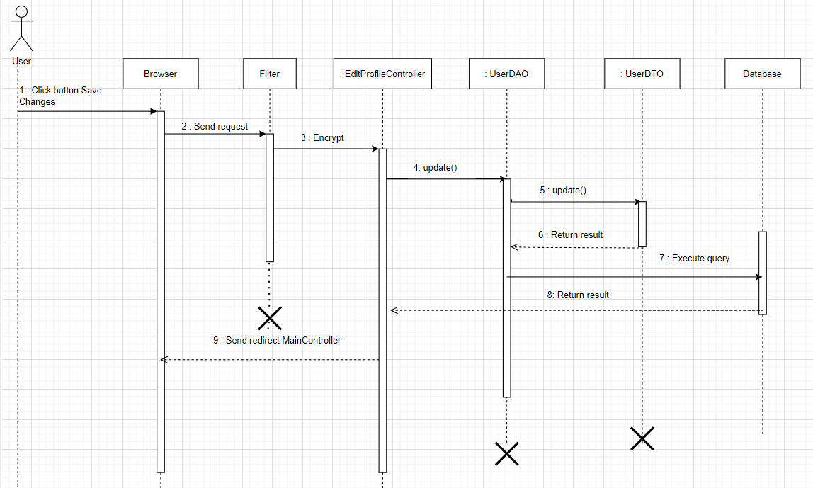

### c. Database queries

Update tblUsers set userName=?, password=?, email=?, phone=?, image=? Where userID=?

## 10. Create Mentor

### a. Class Diagram

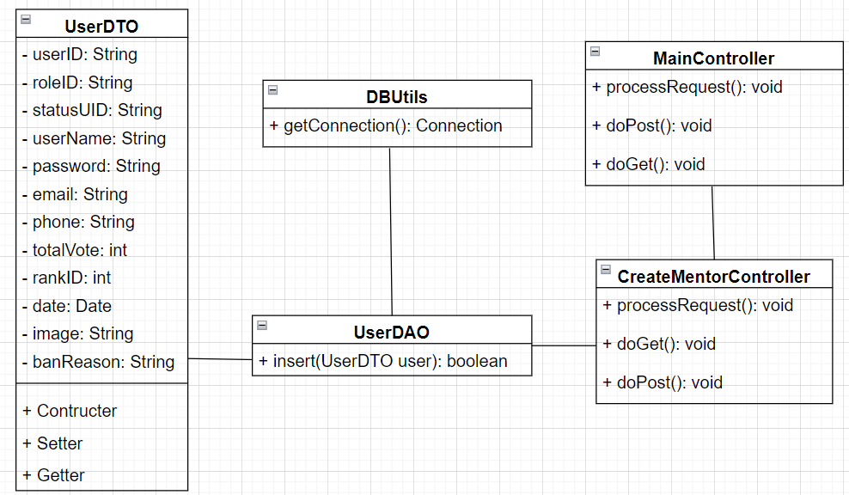

### b. Sequence Diagram(s)

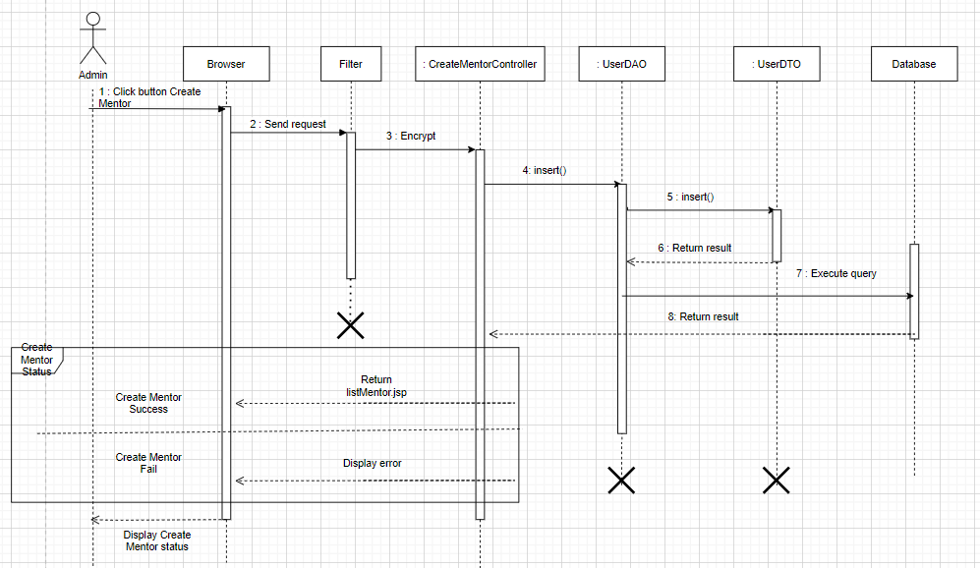

### c. Database queries

INSERT INTO tblUsers(userID, roleID, statusUID, userName, password, email, phone, totalVote, rankID, date, image)

VALUES(?,?,?,?,?,?,?,?,?,?,?)

## 11. Add Category

### a. Class Diagram

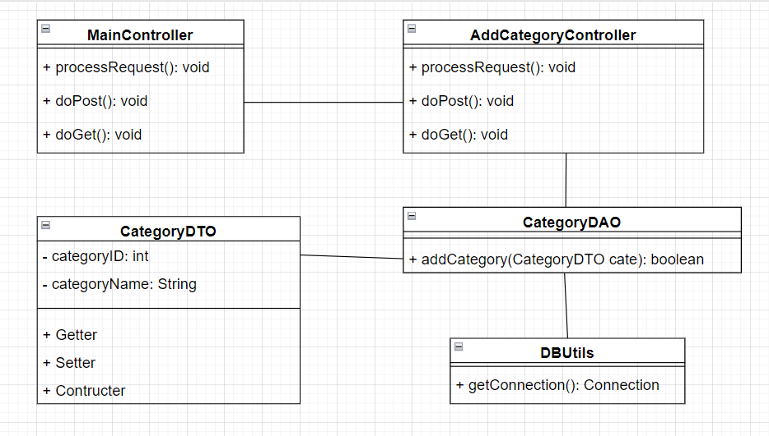

### b. Sequence Diagram(s)

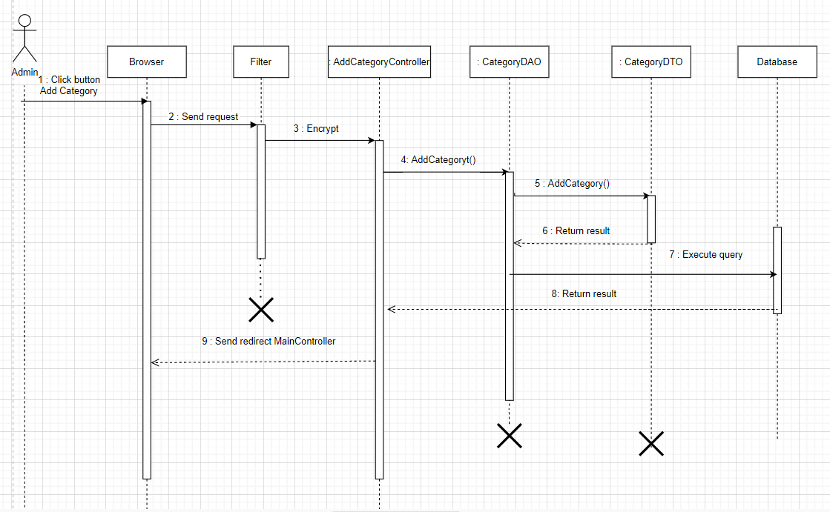

### c. Database queries

INSERT INTO tblCategories(categoryName) VALUES(?)

## 12. Update Category

### a. Class Diagram

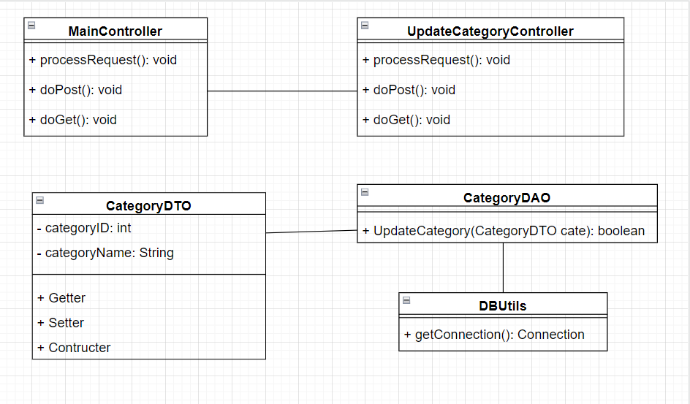

### b. Sequence Diagram(s)

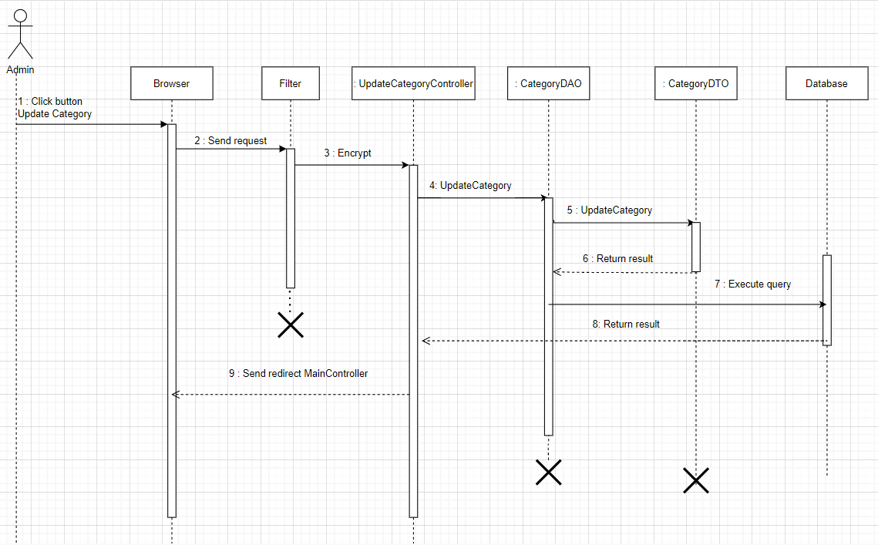

### c. Database queries

update tblCategories set categoryName = ? where categoryID = ?

## 13. Ban User

### a. Class Diagram

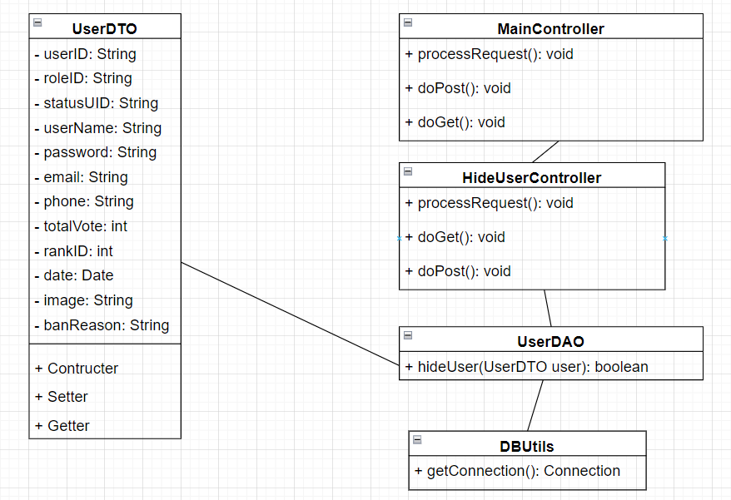

### b. Sequence Diagram(s)

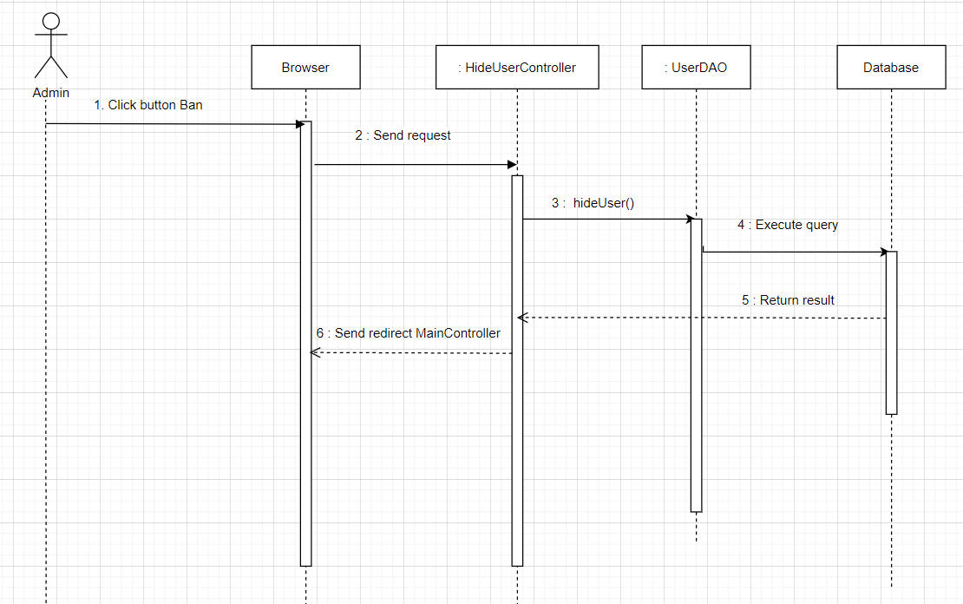

### c. Database queries

UPDATE tblUsers SET statusUID='0', banReason = ? WHERE userID=?

## 14. Approve Post

### a. Class Diagram

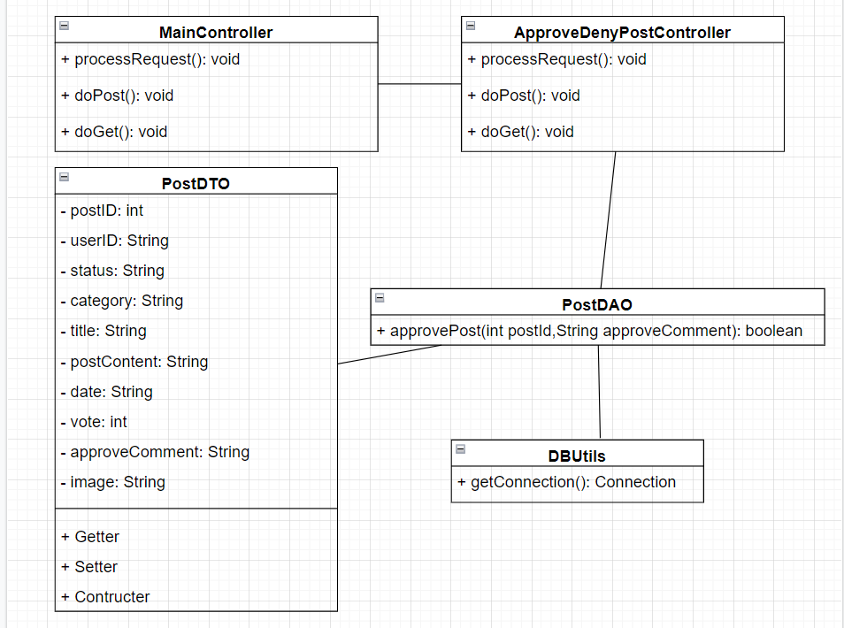

### b. Sequence Diagram(s)

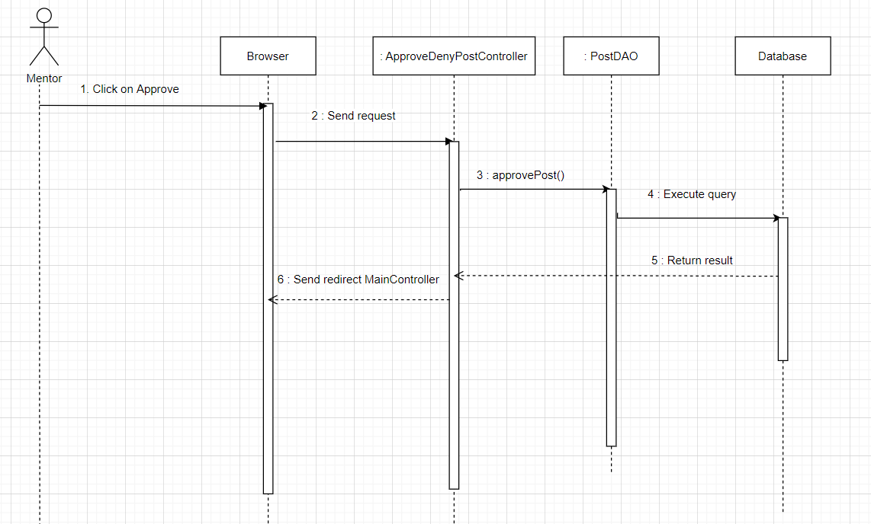

### c. Database queries

Update tblPosts set statusPID=1, approveComment=? where postID=?

## 15. Deny Post

### a. Class Diagram

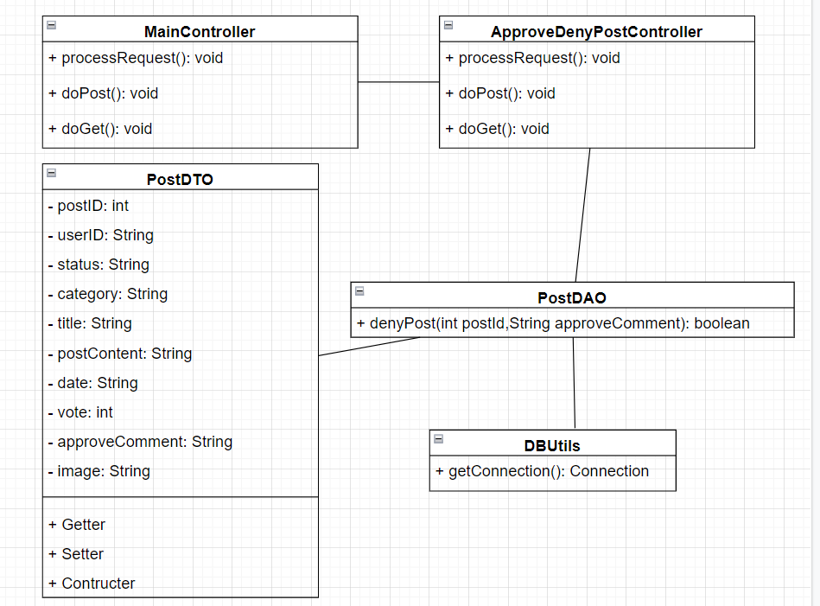

### b. Sequence Diagram(s)

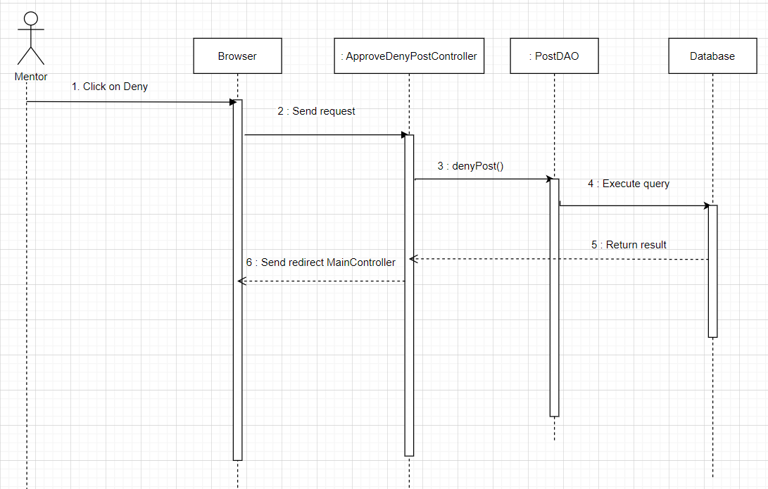

### c. Database queries

Update tblPosts set statusPID=0, approveComment=? where postID=?

## 16. Sign up

### a. Class Diagram

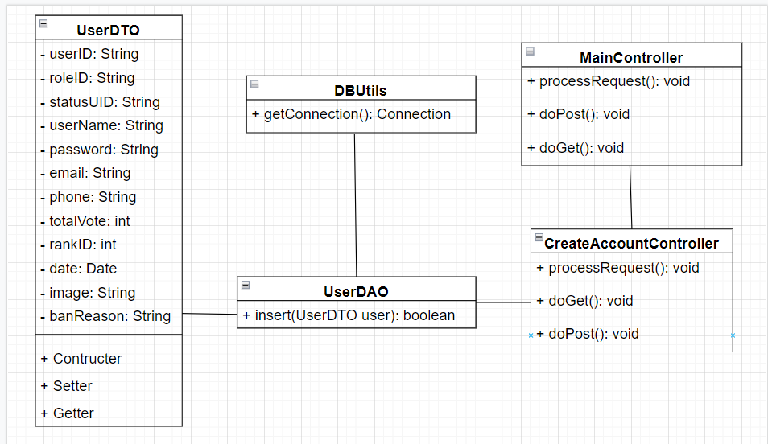

### b. Sequence Diagram(s)

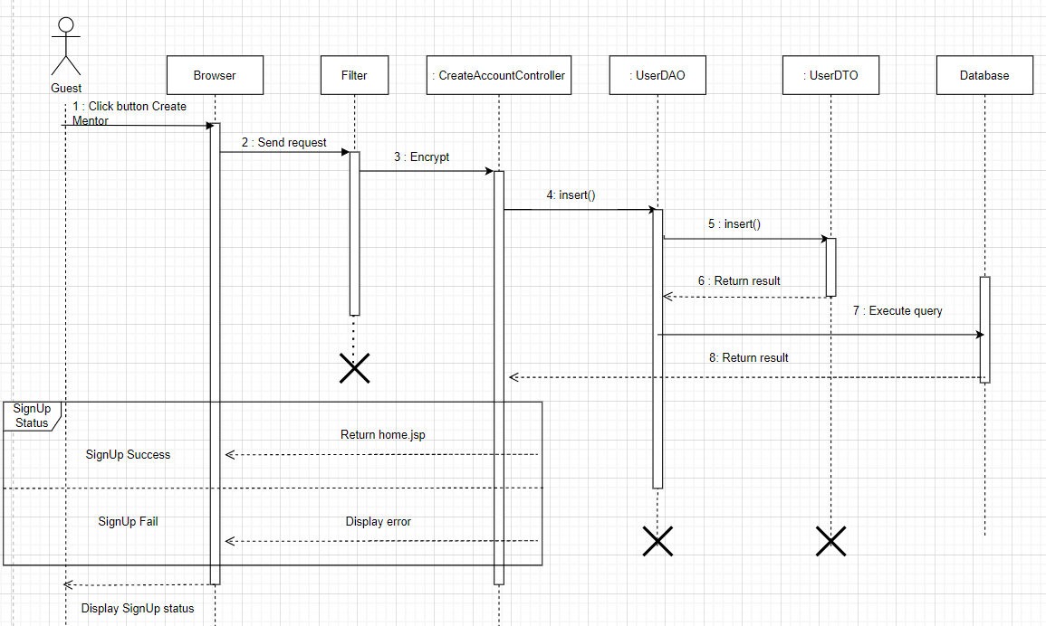

### c. Database queries

INSERT INTO tblUsers(userID, roleID, statusUID, userName, password, email, phone, totalVote, rankID, date, image)

VALUES(?,?,?,?,?,?,?,?,?,?,?)

## 17. Logout

### a. Class Diagram

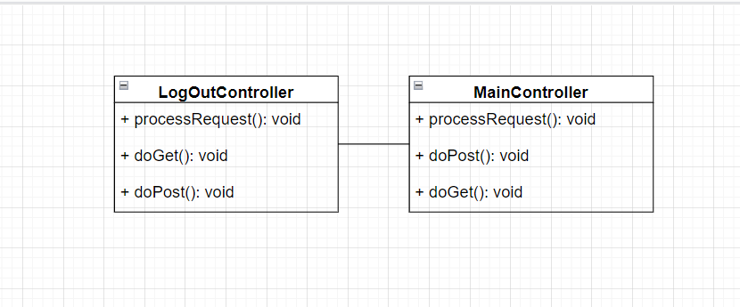

### b. Sequence Diagram(s)



 